**CM1605 Web Technology**

**Tutorial 4**

The aim of this tutorial is to make use of HTML form elements, controls to create a form for a given context. Get use to HTML 5 form elements and add form styling using CSS.

This is an individual exercise. You may use any text editor (Notepad, Notepad ++) to create the HTML pages and any Browser application (chrome, IE, firefox etc) to run the web pages.

Note: Use proper indentation and comments where applicable.

**Task**

You are asked to create a HTML form GUI for an intelligent personalized mobile phone recommendation system. This is a web based application. The sample GUI is shown in the bottom of the document.

***Note: Do not use HTML tables to align form labels and elements.***

Follow the below specification to create the form.

1. Use CSS float to align the form label tags and form controls. (Hint: Use div elements) Use **explicit html form labels**.
2. Make use of HTML fieldset, legend to separate different parts of the form.
3. Include following form controls
   1. Input type:Text
   2. Input type:Number
   3. Input type:Email
   4. Input type:Radio
   5. A select type (either a pop up list or scrolling list).
   6. Checkbox
   7. A form control to reset the form.
   8. A form control to submit the form data.
   9. Input type:Range
   10. Datalist
   11. Textarea
4. Use placeholder attribute for input text fields.
5. Sending a copy of the recommendation to user’s email address is mandatory (Hint: use required attribute)
6. From styling – The form elements (including buttons), labels should be styled (Hint: Use different colors, shades)

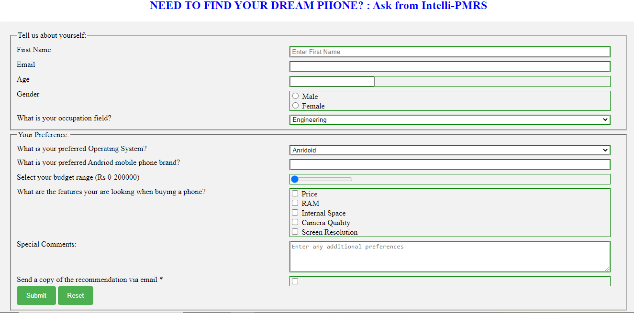

Figure : Sample GUI